Bayesian Belief Network-Driven Proactive Fault Tolerance for Microservice Placement in Fog Computing Environments
Rahul Akshath Rajendran
3122235002095
Mohit R
3122235002072
Dr Sabireen H, Assistant Professor
Project Guide
Department of Information Technology
SSN College of Engineering, Kalavakkam, Chennai, India
{rahul2310405, mohit2310893, sabireenh}@ssn.edu.in
Abstract—Fog computing extends cloud services to the network edge in order to satisfy the stringent latency requirements of Internet-of-Things (IoT) applications such as remote cardiac monitoring, intelligent video surveillance and immersive gaming. The fog nodes that host these applications are, however, heterogeneous, resource-constrained and considerably less reliable than data-centre hardware, so the failure of a single node can breach the deadline of a safety-critical service. Existing fog fault-tolerance mechanisms are predominantly reactive: checkpoint-and-restore, primary-backup replication, acknowledgement-based retransmission and heartbeat-driven failover all take effect only after a fault has already manifested, and therefore incur a recovery latency that latency-critical workloads cannot absorb. The few proactive schemes reported in the literature trigger migration on a single fixed threshold applied to a single metric, which neither captures the multi-causal nature of fog node degradation nor tolerates missing or noisy telemetry. This paper proposes a Bayesian Belief Network (BBN) driven proactive fault-tolerance framework for microservice placement in fog environments. The framework contributes: (i) a causal BBN that infers the posterior probability of node failure within a look-ahead horizon from partial and noisy telemetry and exposes an explainable causal chain rather than an opaque score; (ii) a risk-aware placement and expected-loss migration policy that replaces fixed thresholds with a cost-sensitive decision rule; and (iii) a criticality-aware selective replication scheme that allocates standby capacity in proportion to predicted risk and application criticality. The framework is being realised as an extension to the iFogSim2 simulator and will be evaluated on the Melbourne CBD edge-resource and user-mobility datasets against representative reactive and threshold-based baselines.
Index Terms—Bayesian belief network, fog computing, proactive fault tolerance, microservice placement, reliability, iFogSim2, Internet of Things, probabilistic inference.
I. Introduction
The proliferation of latency-sensitive Internet-of-Things (IoT) applications has exposed a structural limitation of the centralised cloud model. An electrocardiogram stream that must be classified within a few tens of milliseconds, or a surveillance feed that must trigger a pan-tilt-zoom actuator before a tracked object leaves the frame, cannot tolerate the round-trip delay to a distant data centre. Fog computing addresses this by interposing a tier of computational resources — gateways, routers, base stations and micro data centres — between the end devices and the cloud, so that application modules execute within one or two network hops of the sensors that feed them (Mahmud et al. 2022; Gupta et al. 2017).
This proximity is purchased at the cost of reliability. Whereas a cloud data centre offers redundant power, cooling and network paths, a fog node is frequently a commodity device deployed in an uncontrolled environment, sharing a constrained uplink, operating on limited or battery power, and serving mobile users whose handovers continually reshape the load it carries. Empirical studies of distributed infrastructure consistently report that such nodes fail far more often than data-centre hosts, and that failures are rarely instantaneous: a node typically degrades through a period of rising utilisation, thermal stress, queue build-up and link deterioration before it becomes unresponsive (Hasan and Zeebaree 2024). That degradation window is precisely the opportunity that a proactive mechanism should exploit.
The fog fault-tolerance literature has, however, largely declined to exploit it. The dominant mechanisms — dynamic checkpointing (Rajab and Younis 2021), acknowledgement-based retransmission (Syed et al. 2022), heartbeat monitoring with failover to a replicated backup (Naim, Zain, and Jalil 2016) — are reactive by construction. They detect the absence of a response or the loss of a message, and then initiate recovery. For a best-effort workload this is adequate; for a cardiac arrhythmia classifier it means that the very interval during which an alarm should have been raised is consumed by state restoration. Even the schemes that describe themselves as proactive reduce the decision to a single scalar comparison, such as creating a checkpoint whenever CPU utilisation exceeds twenty per cent (Rajab and Younis 2021), or migrating a microservice when a composite health index falls below a preset fault threshold (Gupta and Singh 2025). A fixed threshold on a single metric is simultaneously too eager and too late: it fires on transient load spikes that resolve without incident, and it stays silent when a node is degrading along a dimension the metric does not observe.
What is missing is a principled representation of uncertainty. Fog node health is a latent condition, inferred indirectly from several noisy and mutually dependent indicators, some of which may be unavailable at any given instant because a telemetry agent has itself been affected. Bayesian Belief Networks (BBNs) are the canonical formalism for exactly this situation. A BBN encodes causal structure as a directed acyclic graph and quantifies it with conditional probability tables, supports exact inference of a posterior over an unobserved variable given whatever evidence happens to be available, degrades gracefully when evidence is partial by marginalising over the missing variables, and permits expert knowledge to be combined with observed data (Pearl 1988). BBNs have been applied with documented success to software defect and reliability prediction (Fenton, Neil, and Marquez 2007), to dependability, risk analysis and maintenance in industrial systems (Weber et al. 2012), and to environmental modelling under sparse observation (Aguilera et al. 2011). Their transfer to fog reliability management is natural and, to the best of our knowledge, unexplored.
This paper proposes a proactive fault-tolerance framework in which a BBN estimates, for every fog node, the probability that it will fail within a look-ahead horizon, and in which that posterior drives placement, migration and redundancy decisions. The contributions are threefold:
• A BBN-based failure-prediction engine that infers the posterior probability of imminent node failure from heterogeneous telemetry, tolerates missing and noisy evidence, exposes the causal chain responsible for each prediction, and adapts its conditional probability tables online from observed outcomes.
• A risk-aware placement and expected-loss migration policy in which the BBN posterior enters a multi-objective utility over latency, energy and risk, and in which migration is triggered by a cost-sensitive expected-loss comparison rather than a fixed threshold.
• A criticality-aware selective replication scheme that allocates standby capacity in proportion to the product of predicted risk and application criticality, so that redundancy is spent where it changes the outcome instead of uniformly across all modules.
The remainder of the paper is organised as follows. Section II surveys reactive and proactive fault tolerance in fog computing and the use of BBNs in reliability engineering, and identifies the research gap. Section III presents the proposed framework, its block diagram and its workflow. Section IV describes the simulation environment, the datasets and the evaluation plan. Section V concludes and outlines the work planned for Phase II.
II. Literature Survey
A. Reactive Fault Tolerance in Fog Environments
Rajab and Younis (2021) propose a dynamic fault-tolerance-aware scheduling approach for healthcare systems on fog computing. Their scheme combines Dynamic Weighted Round Robin (DWRR) scheduling, in which each fog server is assigned a weight derived from its current CPU and memory utilisation, with primary-backup replication and dynamic checkpointing. Rather than checkpointing at fixed intervals, the system creates a checkpoint whenever CPU utilisation crosses a threshold of 0.2, and every checkpoint is replicated to a designated backup server so that execution can resume from the most recent saved state if the primary fails. The work demonstrates a clear throughput benefit from load-aware distribution and a reduced re-execution cost from adaptive checkpointing. Its limitations are equally clear: the threshold is fixed and workload-independent, the backup server consumes storage whether or not a failure ever occurs, evaluation is confined to a healthcare scenario, and the system possesses no capacity to anticipate a failure before the threshold condition is met.
Syed et al. (2022) address reliability in vehicular networks through QAFT-SDVN, which integrates software-defined networking with a cloud-fog substrate. A centralised SDN controller classifies each message by type, deadline and size, assigns a priority accordingly, and routes safety-critical traffic such as ambulance alerts to the nearest fog node while queueing non-safety traffic at lower priority. Fault tolerance is provided by acknowledgement-based retransmission: the sender awaits an ACK and retransmits if none arrives within the expected interval. The approach roughly halves response time for prioritised traffic and reduces the message failure ratio, but recovery is purely reactive and consists solely of retransmission. No backup execution, checkpointing or replica management is provided, the additional ACK traffic inflates network load, and the design is specialised to the vehicular domain.
Naim, Zain, and Jalil (2016) place a fog middleware between users and application servers to improve availability. The middleware polls the primary server with heartbeat requests, maintains a replicated backup containing the same application and data, and on detecting the absence of a heartbeat response activates the backup and transparently redirects all subsequent user requests to it. A prototype recovered from three of four simulated failure scenarios without manual intervention. The mechanism is nevertheless strictly detection-driven: it waits until the server has already stopped responding, considers only a single backup so that a correlated double failure is unrecoverable, imposes continuous heartbeat overhead, and performs no load-aware server selection.
B. Optimisation-Based and Threshold-Based Proactive Placement
Reyana et al. (2023) propose QoS-EO, a hybrid task-placement approach that combines Particle Swarm Optimisation with the Artificial Bee Colony algorithm. Candidate solutions encode task-to-node assignments and are scored by a fitness function over response time, energy consumption, reliability, throughput and execution cost; PSO drives the swarm towards better assignments while ABC's worker, onlooker and scout phases refine and diversify the search. Better placement reduces node overload and thereby improves fault tolerance indirectly. The cost is computational: running two metaheuristics in sequence is expensive, performance is sensitive to inertia weight and learning-factor settings, and the search space grows unfavourably as the number of IoT devices increases. Crucially, reliability enters only as a static term in a fitness function; the scheme does not estimate the probability that any particular node will fail.
Gupta and Singh (2025) come closest to a proactive design. Their Fault-Tolerance Aware Placement Algorithm (FTAPA) selects a primary fog node using a Dynamic Connections Load Balancer that evaluates active connections, resource availability and node health; it simultaneously pre-selects a backup node, monitors the health of the primary against a computed fault threshold, and migrates the microservice to the backup before the primary fails outright. This anticipatory migration measurably reduces service downtime relative to detection-driven recovery. The authors themselves identify the residual weaknesses: backup nodes consume memory and processing capacity even when failures never materialise, continuous health monitoring adds overhead, and the fault threshold is difficult to set — too low and migration happens too late, too high and the system migrates unnecessarily. The threshold is a point estimate of a quantity that is inherently uncertain, and no confidence is attached to it.
C. Bayesian Belief Networks for Reliability Prediction
A Bayesian Belief Network is a directed acyclic graph whose vertices are random variables and whose edges encode direct probabilistic dependence, quantified by a conditional probability table for each vertex given its parents. The joint distribution factorises as the product of these local conditionals, which makes exact posterior inference tractable for the sparse structures that arise when causal knowledge is available. The foundational treatment by Pearl (1988) established both the semantics of such networks and the message-passing algorithms that make inference practical.
The formalism has been applied extensively to reliability. Fenton, Neil, and Marquez (2007) use BNs to predict software defects and reliability, arguing that the ability to combine causal process factors with quantitative measures, and qualitative expert judgement with observed data, overcomes well-known limitations of classical metrics-based models; the approach has been deployed by Motorola, Siemens and Philips with reported accuracy. Weber et al. (2012) survey a decade of BN applications to dependability, risk analysis and maintenance, and document a sustained growth in adoption attributable to advantages over Markov chains, fault trees and Petri nets — specifically the capacity to model complex systems with heterogeneous variables, to perform both predictive and diagnostic reasoning, and to update beliefs incrementally as evidence arrives. Aguilera et al. (2011) review BNs in environmental modelling, a domain characterised, like fog telemetry, by sparse and unreliable observation, and emphasise the graceful handling of missing data. More recently, Pang and Abramov (2025) analyse reliability and parameter selection for IoT communication using deep learning, confirming the importance of predictive reliability modelling for IoT while also illustrating the interpretability cost of black-box predictors — a cost that a BBN does not impose.
Two properties make BBNs particularly appropriate for fog node health. First, inference is well-defined under partial evidence: unobserved variables are marginalised out, so a prediction is still produced when a telemetry channel is unavailable, which is precisely the condition likely to coincide with impending failure. Second, the network is diagnostic as well as predictive: having inferred a high failure probability, the same model identifies which parent variables are most responsible, yielding an explanation that an operator can act on and that a threshold comparison cannot provide.
D. Comparative Analysis
TABLE I. COMPARATIVE ANALYSIS OF FAULT-TOLERANCE MECHANISMS IN FOG COMPUTING
Study | Technique | Nature | Key Limitation
Rajab and Younis (2021) | DWRR scheduling + dynamic checkpointing + primary-backup replication | Reactive | Fixed CPU threshold (0.2); backup storage always reserved; no failure prediction
Syed et al. (2022) | SDN priority scheduling + ACK-based retransmission | Reactive | Recovery limited to retransmission; extra ACK traffic; vehicular domain only
Naim, Zain, and Jalil (2016) | Fog middleware + heartbeat monitoring + replicated failover | Reactive | Acts only after server stops responding; single backup; continuous heartbeat overhead
Reyana et al. (2023) | QoS-EO hybrid PSO + ABC task placement | Preventive (static) | High computational cost; parameter-sensitive; reliability is a static fitness term
Gupta and Singh (2025) | FTAPA: DCLB node selection + threshold-based proactive migration | Proactive (threshold) | Fault threshold hard to tune; backup reserved per microservice; monitoring overhead
This work | Causal BBN inference + expected-loss migration + criticality-aware replication | Proactive (probabilistic) | Requires CPT elicitation and online calibration; addressed by literature priors and Bayesian parameter learning

E. Inferences Drawn from the Survey
Read together rather than individually, the five systems support six inferences that shape the design proposed in this paper.
1) Fault tolerance in fog computing is overwhelmingly reactive. Three of the five systems act only once a fault has been detected — by a missing heartbeat (Naim, Zain, and Jalil 2016), an unacknowledged message (Syed et al. 2022) or a threshold breach during execution (Rajab and Younis 2021) — so the recovery latency is incurred at precisely the moment the application can least absorb it.
2) Acting before failure demonstrably helps. FTAPA (Gupta and Singh 2025) reports measurably reduced service downtime from migrating a microservice ahead of a predicted failure. The principle is sound, and this paper builds on it rather than disputing it.
3) Where prediction is attempted it is deterministic and single-metric. Both Rajab and Younis (2021) and Gupta and Singh (2025) reduce the decision to a comparison of one scalar against a preset threshold, and the authors of both report the difficulty of choosing that threshold as an open limitation.
4) Node health is treated as directly observable. No surveyed system represents it as a latent condition that must be inferred from indicators which are noisy, mutually dependent and sometimes absent — despite the fact that a telemetry channel is most likely to fall silent exactly when the node hosting it is degrading.
5) Redundancy is provisioned uniformly rather than by risk. A backup is reserved per task (Rajab and Younis 2021), per server (Naim, Zain, and Jalil 2016) or per microservice (Gupta and Singh 2025), consuming standby capacity irrespective of whether a failure is likely; Gupta and Singh (2025) identify this as a standing cost of their own design.
6) Reliability enters optimisation only as a static term. QoS-EO (Reyana et al. 2023) scores reliability within a fitness function but never estimates the probability that a particular node will fail within a particular interval, so its reliability term cannot respond to changing conditions.
Taken together, these inferences point to a single conclusion: what the field lacks is a probabilistic and explainable estimate of imminent node failure, together with a decision rule that spends migration and redundancy in proportion to that estimate.
F. Selection of the Modelling Approach
Several established formalisms could in principle supply such an estimate, and the choice among them was made against four requirements imposed by the problem: the method must function without a large corpus of labelled failures, since none exists for fog topologies; it must continue to produce an estimate when part of the telemetry is unavailable; it must emit a calibrated probability, because the decision rule proposed in Section III multiplies that probability by a cost; and it must be interpretable, so that an operator can act on the reason for a prediction rather than only its magnitude. Table II summarises the candidates against these requirements.
TABLE II. SELECTION OF THE MODELLING APPROACH
Candidate approach | Meets requirements? | Principal reason
Fixed threshold rules | No | Single metric; no uncertainty; silent under missing telemetry; threshold hard to tune
Metaheuristics (PSO, ABC, GA) | No | Optimises assignment but never estimates node failure; costly and parameter-sensitive
Markov chains / fault trees | Partly | State-space explosion; poor with partial evidence; static structure
ML classifiers / deep learning | Partly | Needs a large labelled failure corpus; miscalibrated outputs; requires imputation; opaque
Bayesian Belief Network | Yes | Priors usable without data; marginalises missing evidence; calibrated posterior; causally explainable

Fixed threshold rules fail the first three requirements outright. Metaheuristic placement optimises an assignment but never estimates failure at all. Markov chains and fault trees, the classical instruments of reliability analysis, suffer state-space explosion on systems of this size and accommodate partial evidence poorly — precisely the comparison Weber et al. (2012) draw in concluding that Bayesian networks have displaced them across dependability and maintenance applications. Discriminative machine learning, including the deep-learning approach that Pang and Abramov (2025) apply to IoT reliability, achieves high accuracy where abundant labelled data exists, but requires an input value in every feature slot and so must impute the very channels whose absence is diagnostic; its confidence scores are also well known to be poorly calibrated, which matters when the output is to be multiplied by a cost.
A Bayesian Belief Network satisfies all four requirements simultaneously. Its conditional probability tables can be initialised from expert judgement and published reliability priors and then refined from observation, so it is usable from the first epoch. Inference marginalises over unobserved variables, so partial telemetry degrades the sharpness of the posterior without preventing a decision. The output is a probability in the formal sense, suitable for composition with a loss function. And because the graph encodes causal structure, the same inference that produces the posterior also identifies the parent configuration most responsible for it. This combination, rather than any single property, is why the Bayesian Belief Network was selected.
G. Research Gap
Table I makes the gap explicit. Every surveyed fault-tolerance mechanism either reacts to a fault that has already occurred, or anticipates it using a deterministic comparison against a fixed threshold on a small number of directly observed metrics. None represents node health as a latent variable, none quantifies the uncertainty of its own prediction, none continues to reason when telemetry is incomplete, and none uses a predicted failure probability to modulate how much redundancy a given module deserves. Conversely, the BBN literature provides a mature apparatus for probabilistic reliability inference under uncertainty, but has not been applied to the fog placement problem. This paper addresses that intersection.
III. Proposed Methodology
A. System Architecture
Fig. 1 presents the proposed framework. It preserves the conventional three-tier fog topology — an IoT and end-device layer, a fog layer and a cloud layer — and introduces a Proactive Fault-Tolerance Controller that is co-located with the Fog Orchestration Node at the proxy tier of the hierarchy, where it has visibility of an entire cluster of fog nodes without incurring the round-trip delay of a cloud-hosted controller.
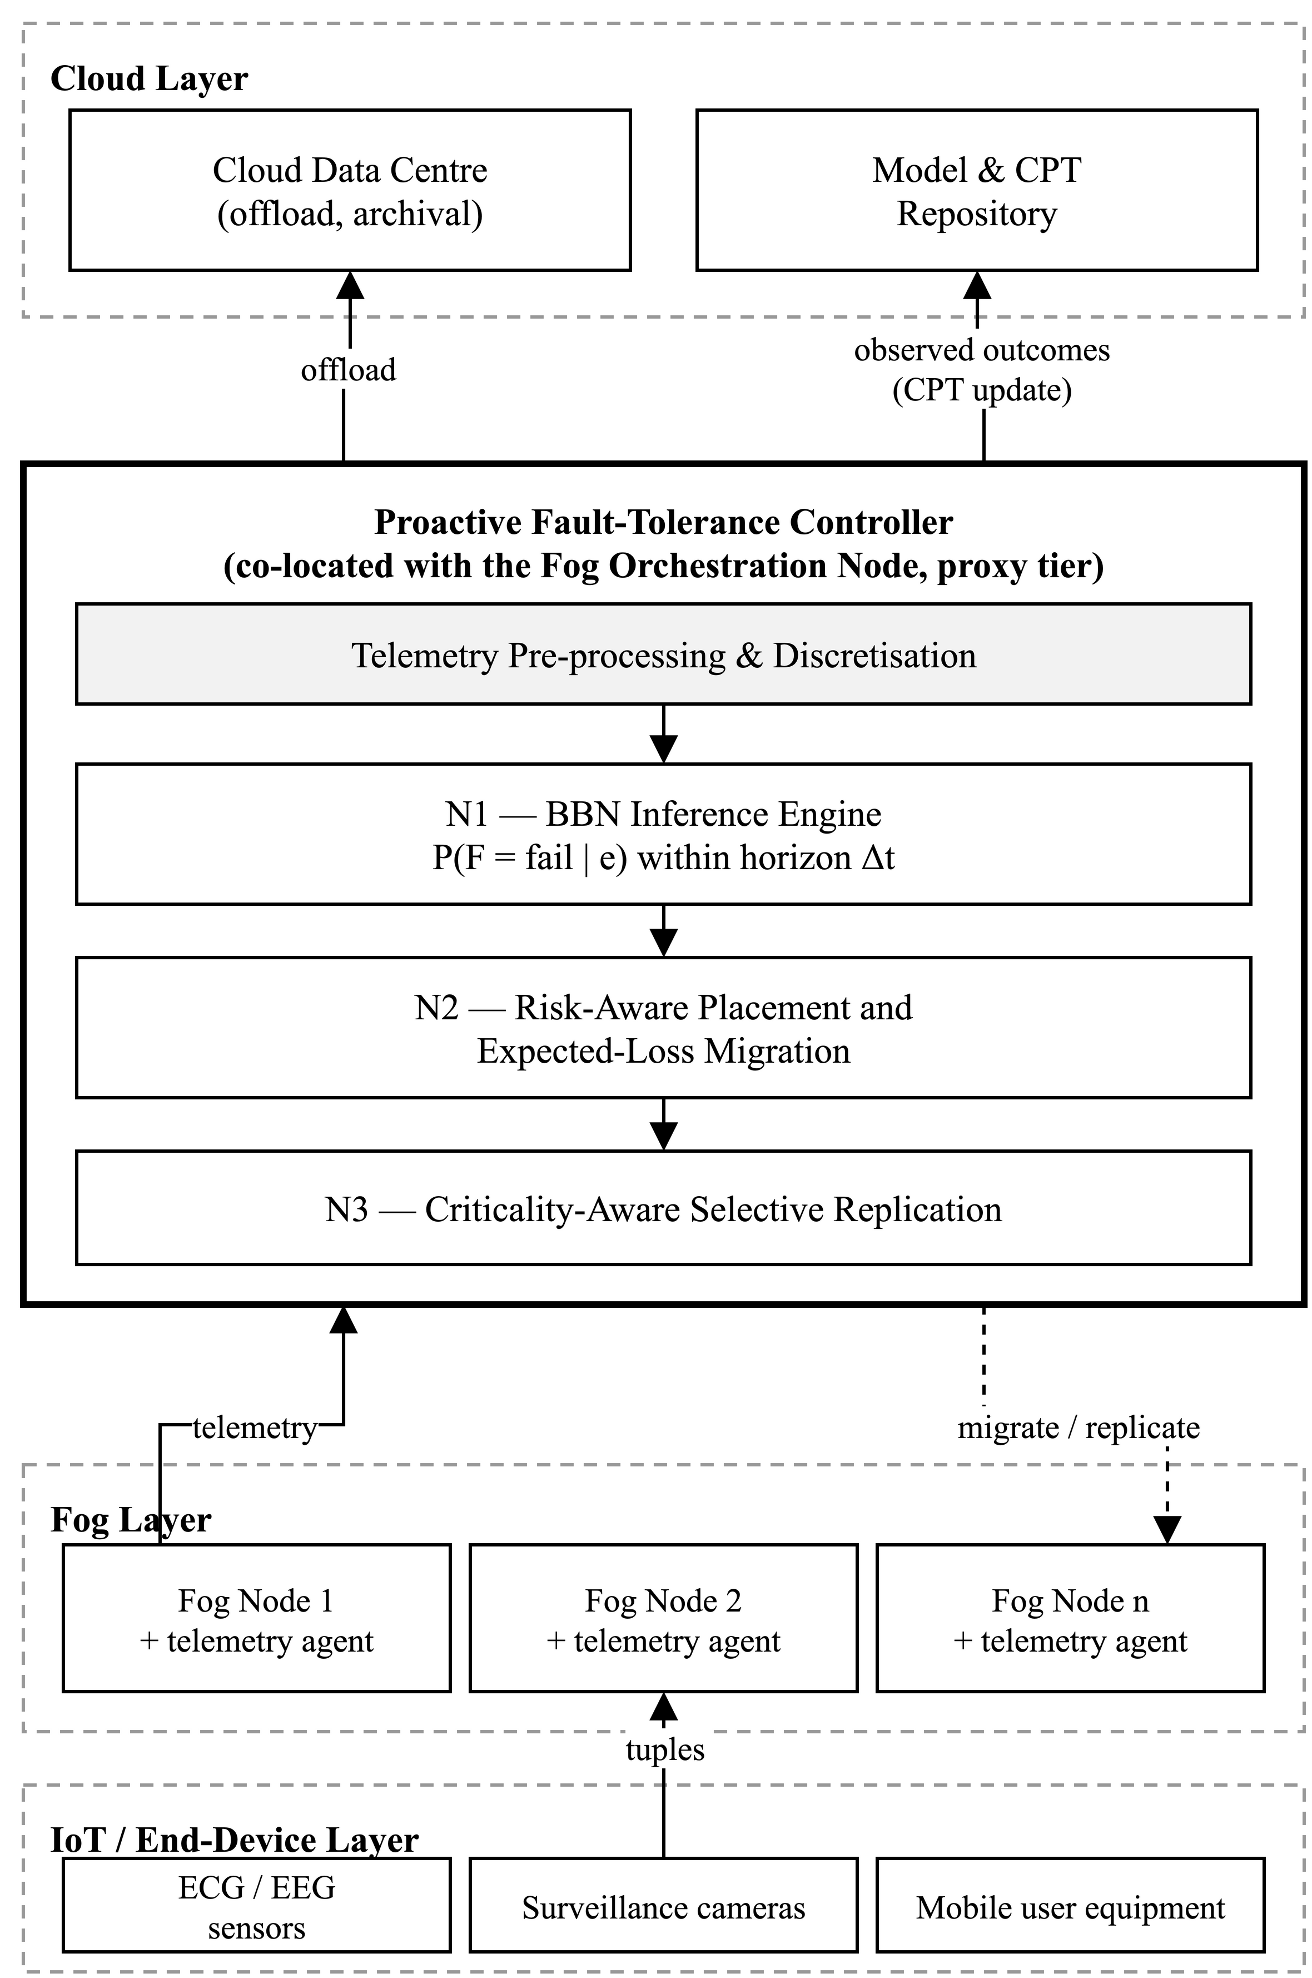
Fig. 1. Block diagram of the proposed BBN-driven proactive fault-tolerance framework. Telemetry from the fog layer is discretised and supplied as evidence to the BBN inference engine (N1); the resulting posterior drives risk-aware placement and expected-loss migration (N2) and criticality-aware selective replication (N3). Observed outcomes are fed back for online conditional-probability-table adaptation.
At the lowest layer, sensors and end devices — electrocardiogram and electroencephalogram sensors, surveillance cameras and mobile user equipment — emit tuples that are consumed by application modules placed on fog nodes. Every fog node hosts a lightweight telemetry agent that periodically reports the observable indicators of node condition. The controller consumes this telemetry through the four stages drawn inside it in Fig. 1. A pre-processing and discretisation stage cleans, aligns and bins the continuous measurements into the ordinal states over which the network is defined. The BBN inference engine (N1) then computes, for each node, the posterior probability of failure within the look-ahead horizon. The risk-aware placement and migration module (N2) converts those posteriors into placement and migration decisions, and the criticality-aware replication module (N3) decides how much standby capacity each placed module should be granted. Decisions are actuated back onto the fog nodes as module placements, live migrations and replica allocations, while modules that no fog node can safely host are offloaded to the cloud. Observed outcomes — whether a node predicted to fail actually failed — are fed back to update the conditional probability tables, and the updated tables are synchronised with a cloud-hosted repository so that knowledge learned in one cluster benefits others.
B. Novelty 1: BBN-Based Failure Prediction Engine
The core of the framework is a Bayesian Belief Network over fog-node condition, whose structure is shown in Fig. 2. The network is organised in three tiers. Observable evidence variables correspond directly to telemetry: CPU utilisation, RAM utilisation, tuple queue depth, uplink latency, jitter and packet loss, residual energy or battery level, ambient or die temperature, and the handover rate induced by user mobility. Intermediate latent variables aggregate these into interpretable conditions — computational stress, network degradation, energy stress and thermal stress. A single target variable, the failure of the node within the horizon, is the child of the intermediate tier, additionally conditioned on a node-reliability prior derived from the device class and its historical mean time between failures.
The edges follow the physical origin of each indicator. CPU utilisation, RAM utilisation and tuple queue depth are the parents of computational stress; uplink latency, jitter with packet loss, and handover rate are the parents of network degradation; residual energy is the parent of energy stress; and temperature is the parent of thermal stress. Those four latent variables, together with the node-reliability prior, are in turn the parents of the target. Each variable is discretised into a small ordinal state space, { low, medium, high }, so that conditional probability tables remain compact and interpretable. Given the set of evidence actually observed at a decision epoch, the engine computes the posterior
P(F = fail | e) = [ Σ_{u} Π_{V} P(V | pa(V)) ] / P(e) (1)
where
P(F = fail | e) — the posterior probability, given the evidence actually observed, that the node fails within the look-ahead horizon; this single number is what drives every decision in Sections III.C and III.D.
F — the target variable of the network, taking the states fail and not-fail, where fail means “the node becomes unable to host its modules at some point within the next Δt”.
Δt — the look-ahead horizon: the length of the interval over which failure is predicted, chosen so that it exceeds the time needed to migrate a module.
e — the evidence, that is, the set of observed states of those telemetry variables that actually reported at this decision epoch. Channels that failed to report are simply absent from e rather than imputed.
Σ_{u} — the summation over u, and the step that gives the network its tolerance of missing telemetry: every possible combination of values for the variables that were not observed is enumerated and its contribution added up, which is what marginalising them out means.
u — one such joint assignment of states to the unobserved variables — the latent conditions, plus any telemetry channel missing from e.
Π_{V} — the product over V, taken across every variable of the network. Multiplying the local conditional probabilities together in this way reconstitutes the full joint distribution, and is what makes exact inference tractable on a sparse graph.
V — an individual variable of the network. The product runs over all fourteen of them: the eight evidence variables, the four latent condition variables, the node-reliability prior and F itself.
pa(V) — the parents of V in the directed acyclic graph, so that P(V | pa(V)) is exactly the conditional probability table stored at V.
P(e) — the normalising constant, obtained by summing the same expression over both states of F as well as over u, so that the two posterior probabilities sum to one.
This is the property that distinguishes the approach from a threshold rule and from a discriminative classifier: a missing telemetry channel widens the sum over u and so degrades the sharpness of the posterior, but it does not prevent a decision from being made, whereas a threshold on an unreported metric simply never fires.
With one exception, every evidence variable is derived from a quantity the simulator described in Section IV already maintains. CPU utilisation is allocated MIPS against host capacity per scheduling interval; RAM utilisation comes from the memory provisioner; queue depth is the pending tuple queue on the device; uplink latency and jitter combine the configured link delay with queueing delay; residual energy is accumulated consumption against a configured budget; and handover rate is the count of parent reassignments per window, while the node-reliability prior is fixed by device class and configured mean time between failures. Temperature is read wherever a node exposes a thermal sensor; where none is exposed, as on the simulated devices of Section IV, that variable is left unobserved and is marginalised out by (1) — the partial-evidence case the network is built to absorb, rather than a gap that has to be filled in. Continuous quantities are discretised using quantiles of the baseline runs, so that a state such as high CPU utilisation is defined relative to the observed distribution of this topology rather than by an arbitrary cut-off.
Conditional probability tables are initialised from the reliability literature (Fenton, Neil, and Marquez 2007; Weber et al. 2012; Pang and Abramov 2025) and from expert elicitation over the device classes present in the topology, since no public failure trace exists for the fog topology under study. They are subsequently refined online: each prediction is paired with the outcome eventually observed, and the relevant table entries are updated by Bayesian parameter learning with Dirichlet priors, so the model becomes progressively better calibrated to the deployment it governs. Because the network is causal rather than correlational, the posterior is accompanied by the most influential parent configuration, giving an explanation of the form “failure probability is high principally because network degradation is high given elevated jitter and packet loss” — information that supports both operator trust and the choice of remedy.
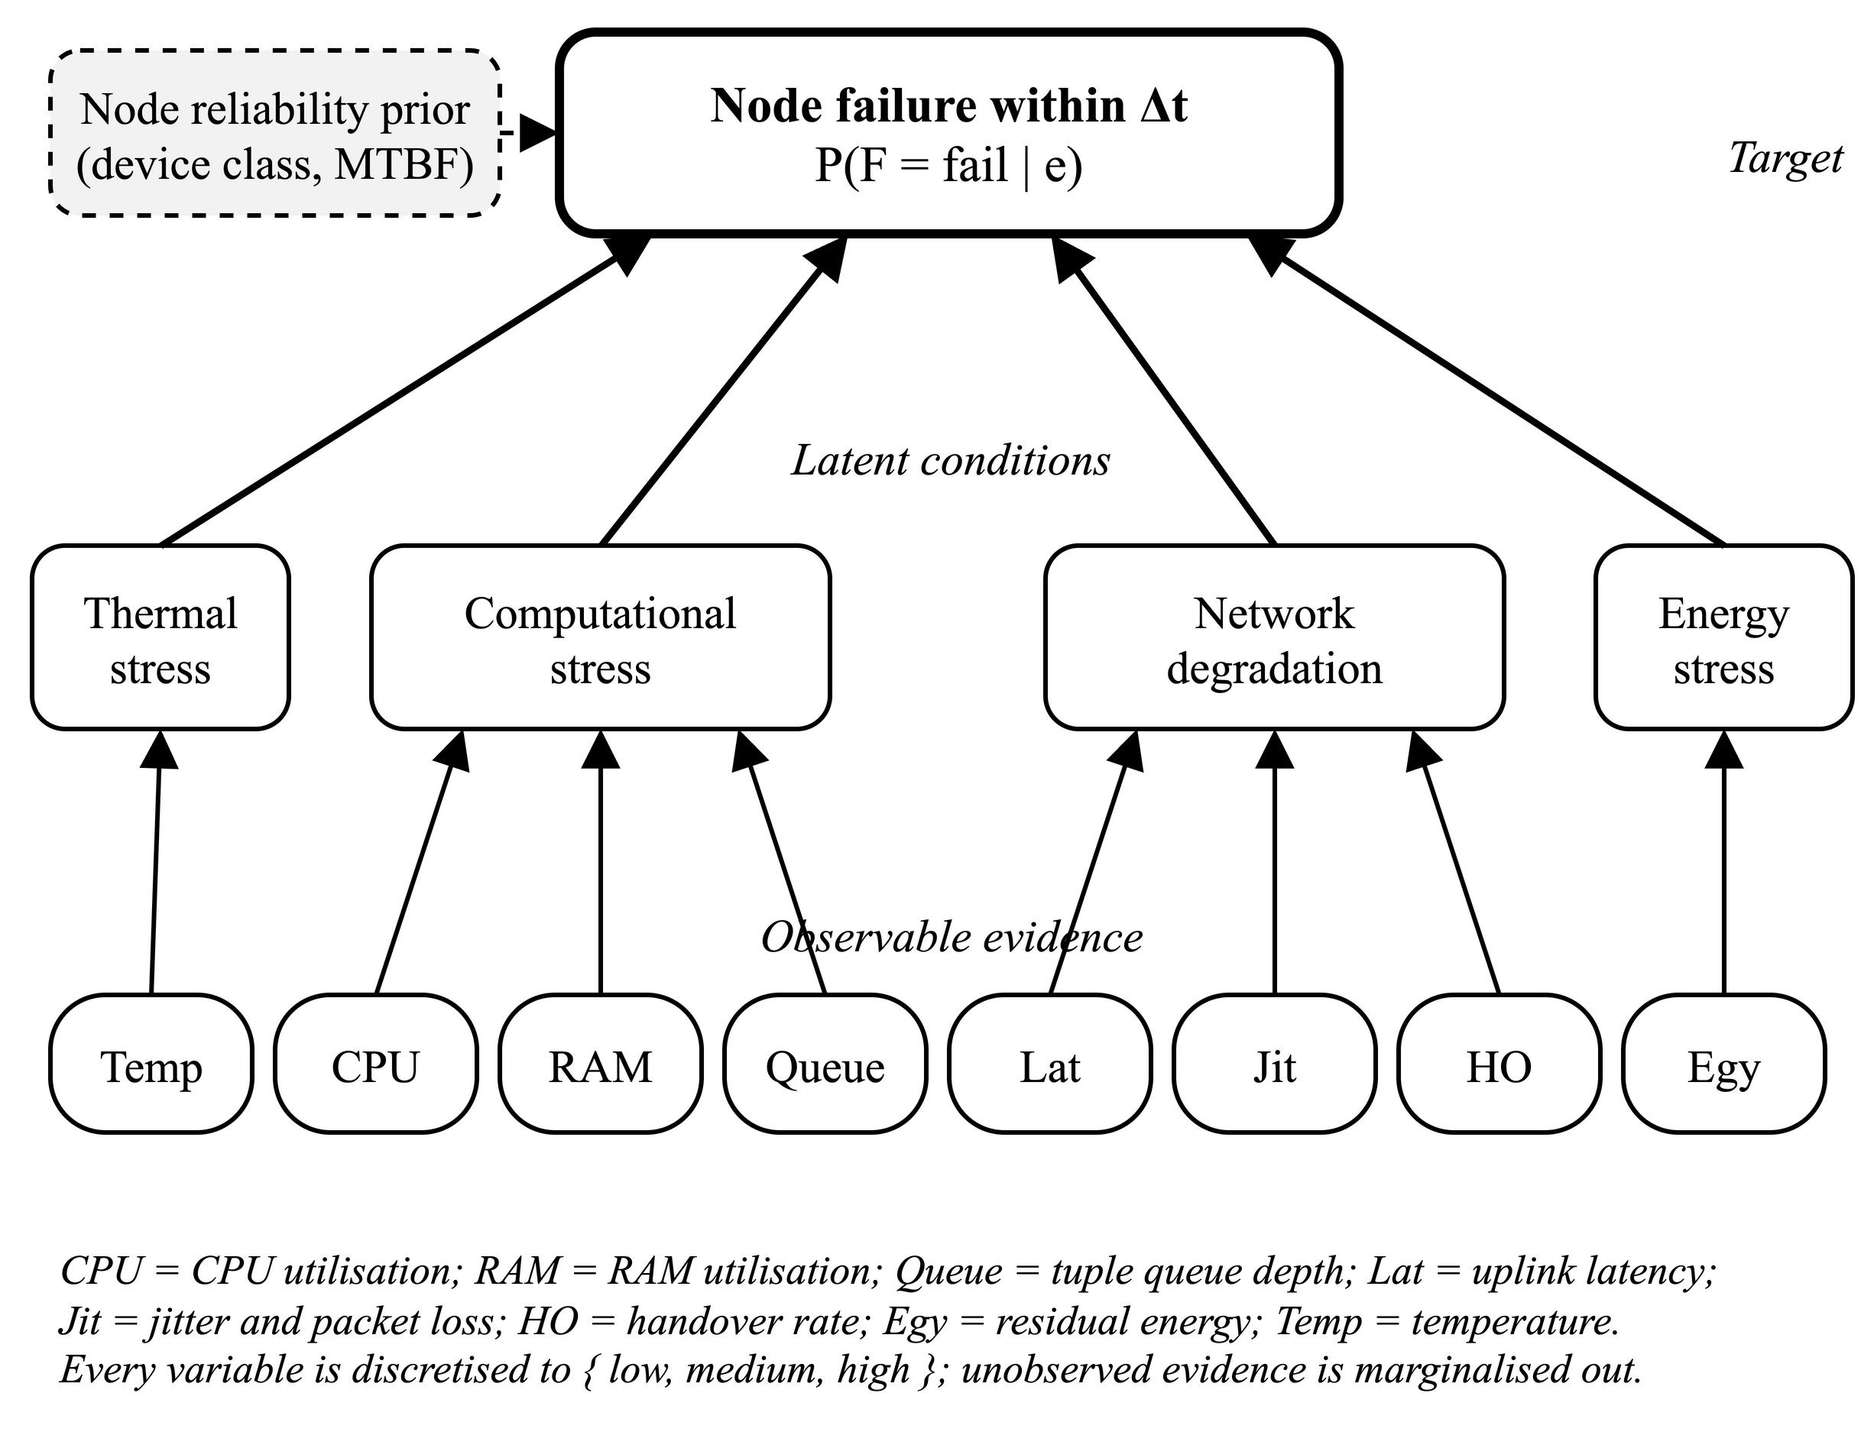
Fig. 2. Structure of the Bayesian Belief Network over fog-node condition. Observable telemetry forms the evidence tier; four latent variables aggregate it into interpretable conditions; the target is failure of the node within the horizon Δt, additionally conditioned on a node-reliability prior derived from the device class and its historical mean time between failures. Evidence that is unavailable at a decision epoch is marginalised out rather than imputed.
C. Novelty 2: Risk-Aware Placement and Expected-Loss Migration
The posterior produced by the BBN is not consumed as a binary alarm. For placement, the controller scores each candidate node for a given module by a normalised multi-objective utility
U(m, n) = α · (1 − L̂(m, n)) + β · (1 − Ê(m, n)) + γ · (1 − P(F_{n} = fail | e)) (2)
where
U(m, n) — the placement utility of hosting module m on node n, on a scale of 0 to 1; the controller places each module on the feasible node of highest utility.
m — the application module, that is, the microservice awaiting placement.
n — the candidate fog node being scored.
L̂(m, n) — the predicted end-to-end latency of running m on n, normalised to the interval 0 to 1 across the candidate nodes; it is subtracted from 1 so that low latency raises the utility.
Ê(m, n) — the predicted energy cost of running m on n, normalised the same way and likewise subtracted from 1.
P(F_{n} = fail | e) — the posterior failure probability of node n from (1); the term 1 − P(F_{n} = fail | e) is therefore the reliability of n as the network currently estimates it.
α, β, γ — non-negative weights on latency, energy and risk respectively, summing to 1 and configured per application class.
The weights are what make the utility application-aware. A latency-critical health module is configured with a large γ, so it is steered away from nodes the network considers fragile even when they are computationally attractive; a best-effort module weights latency and energy more heavily instead.
For migration, the framework replaces the fixed fault threshold of prior work with a cost-sensitive decision. Migrating a running module is not free: it consumes bandwidth, incurs a brief service interruption and may place the module on a less favourable node. Migration is therefore triggered only when the expected loss from remaining exceeds the cost of moving,
P(F_{n} = fail | e) · C_{fail}(m) > C_{mig}(m, n → n′) (3)
where
P(F_{n} = fail | e) · C_{fail}(m) — the left-hand side: the expected loss of leaving m on n for one more decision epoch, being the probability of the loss multiplied by its magnitude.
C_{fail}(m) — the penalty attributable to losing module m — itself a function of the application's criticality and deadline, so that a cardiac classifier carries a far larger value than a best-effort module.
C_{mig}(m, n → n′) — the estimated cost of relocating m from its current node n to the alternative node n′, covering the bandwidth needed to transfer state, the brief interruption to service, and any utility given up by moving to a less favourable node.
n′ — the best alternative node, namely the node that maximises the utility U(m, n) of (2) among the feasible candidates.
The decision rule is self-calibrating: a module whose failure is cheap tolerates a high failure probability before it is moved, while a module whose failure is expensive is moved on comparatively weak evidence. Rearranging (3) makes this explicit — the module migrates once P(F_{n} = fail | e) exceeds the ratio C_{mig} / C_{fail} — so the effective threshold is derived per module from the relative cost of failing and moving. This directly answers the threshold-selection difficulty acknowledged by Rajab and Younis (2021) and Gupta and Singh (2025), because there is no longer a single global threshold to select.
D. Novelty 3: Criticality-Aware Selective Replication
Prior schemes provision a backup for every protected task (Rajab and Younis 2021; Naim, Zain, and Jalil 2016) or pre-select a backup node for every placed microservice (Gupta and Singh 2025). The standby capacity so reserved is consumed whether or not a failure occurs, which Gupta and Singh (2025) identify as a standing cost of their design. The proposed framework instead treats redundancy as a resource to be allocated where it changes the outcome. Each module is assigned a criticality weight reflecting the consequence of its loss, and the controller computes a risk score
R(m) = P(F_{n} = fail | e) · κ(m) (4)
where
R(m) — the risk score of module m: the expected consequence of its loss over the coming horizon, and the quantity on which its redundancy tier is decided.
P(F_{n} = fail | e) — the posterior failure probability from (1) for the node n that currently hosts m.
κ(m) — the criticality weight of m, on a scale of 0 to 1, reflecting the consequence of losing it — near 1 for a cardiac arrhythmia classifier, near 0 for a best-effort module. It is the same criticality that enters C_{fail}(m) in (3).
Modules are then assigned to one of three redundancy tiers by comparing R(m) against two boundaries τ_{high} and τ_{mid}. High-risk, high-criticality modules, for which R(m) ≥ τ_{high} — a cardiac arrhythmia classifier on a node the network judges fragile — receive a warm standby on a pre-selected low-risk node, with state synchronised so that failover is immediate. Modules of intermediate risk, τ_{mid} ≤ R(m) < τ_{high}, receive periodic state checkpointing without a dedicated standby, so that recovery requires re-instantiation but not re-execution. Low-risk, best-effort modules, for which R(m) < τ_{mid}, receive no redundancy and are simply restarted if they fail. Because tier assignment is recomputed as posteriors change, standby capacity follows risk dynamically rather than being pinned at placement time, and the aggregate redundancy overhead is bounded by a configurable capacity budget B that the controller respects when admitting modules to the highest tier: where the budget is exhausted, the modules of greatest R(m) hold the warm standbys.
E. End-to-End Workflow
The framework operates as a continuous control loop over discrete decision epochs, summarised in Fig. 3:
1) Telemetry agents on every fog node report the observable indicators to the controller.
2) The pre-processing stage aligns, cleans and discretises the measurements into the ordinal states of the evidence variables, flagging any channel that failed to report.
3) The BBN inference engine computes the posterior failure probability for every node by (1), marginalising over unobserved evidence, and records the dominant causal explanation.
4) For newly arriving modules, the risk-aware placement policy ranks candidate nodes by the multi-objective utility (2) and places each module on the highest-scoring feasible node.
5) For running modules, the expected-loss rule (3) is evaluated; modules for which the expected failure loss exceeds the migration cost are migrated pre-emptively to the best alternative node.
6) The replication manager recomputes the risk scores (4), assigns modules to redundancy tiers and provisions or releases standby capacity subject to the redundancy budget.
7) Actuated decisions are applied to the fog layer; modules that no fog node can safely host are offloaded to the cloud.
8) Observed outcomes are compared against predictions, the conditional probability tables are updated by Bayesian parameter learning, and the revised tables are synchronised with the cloud repository before the next epoch begins.
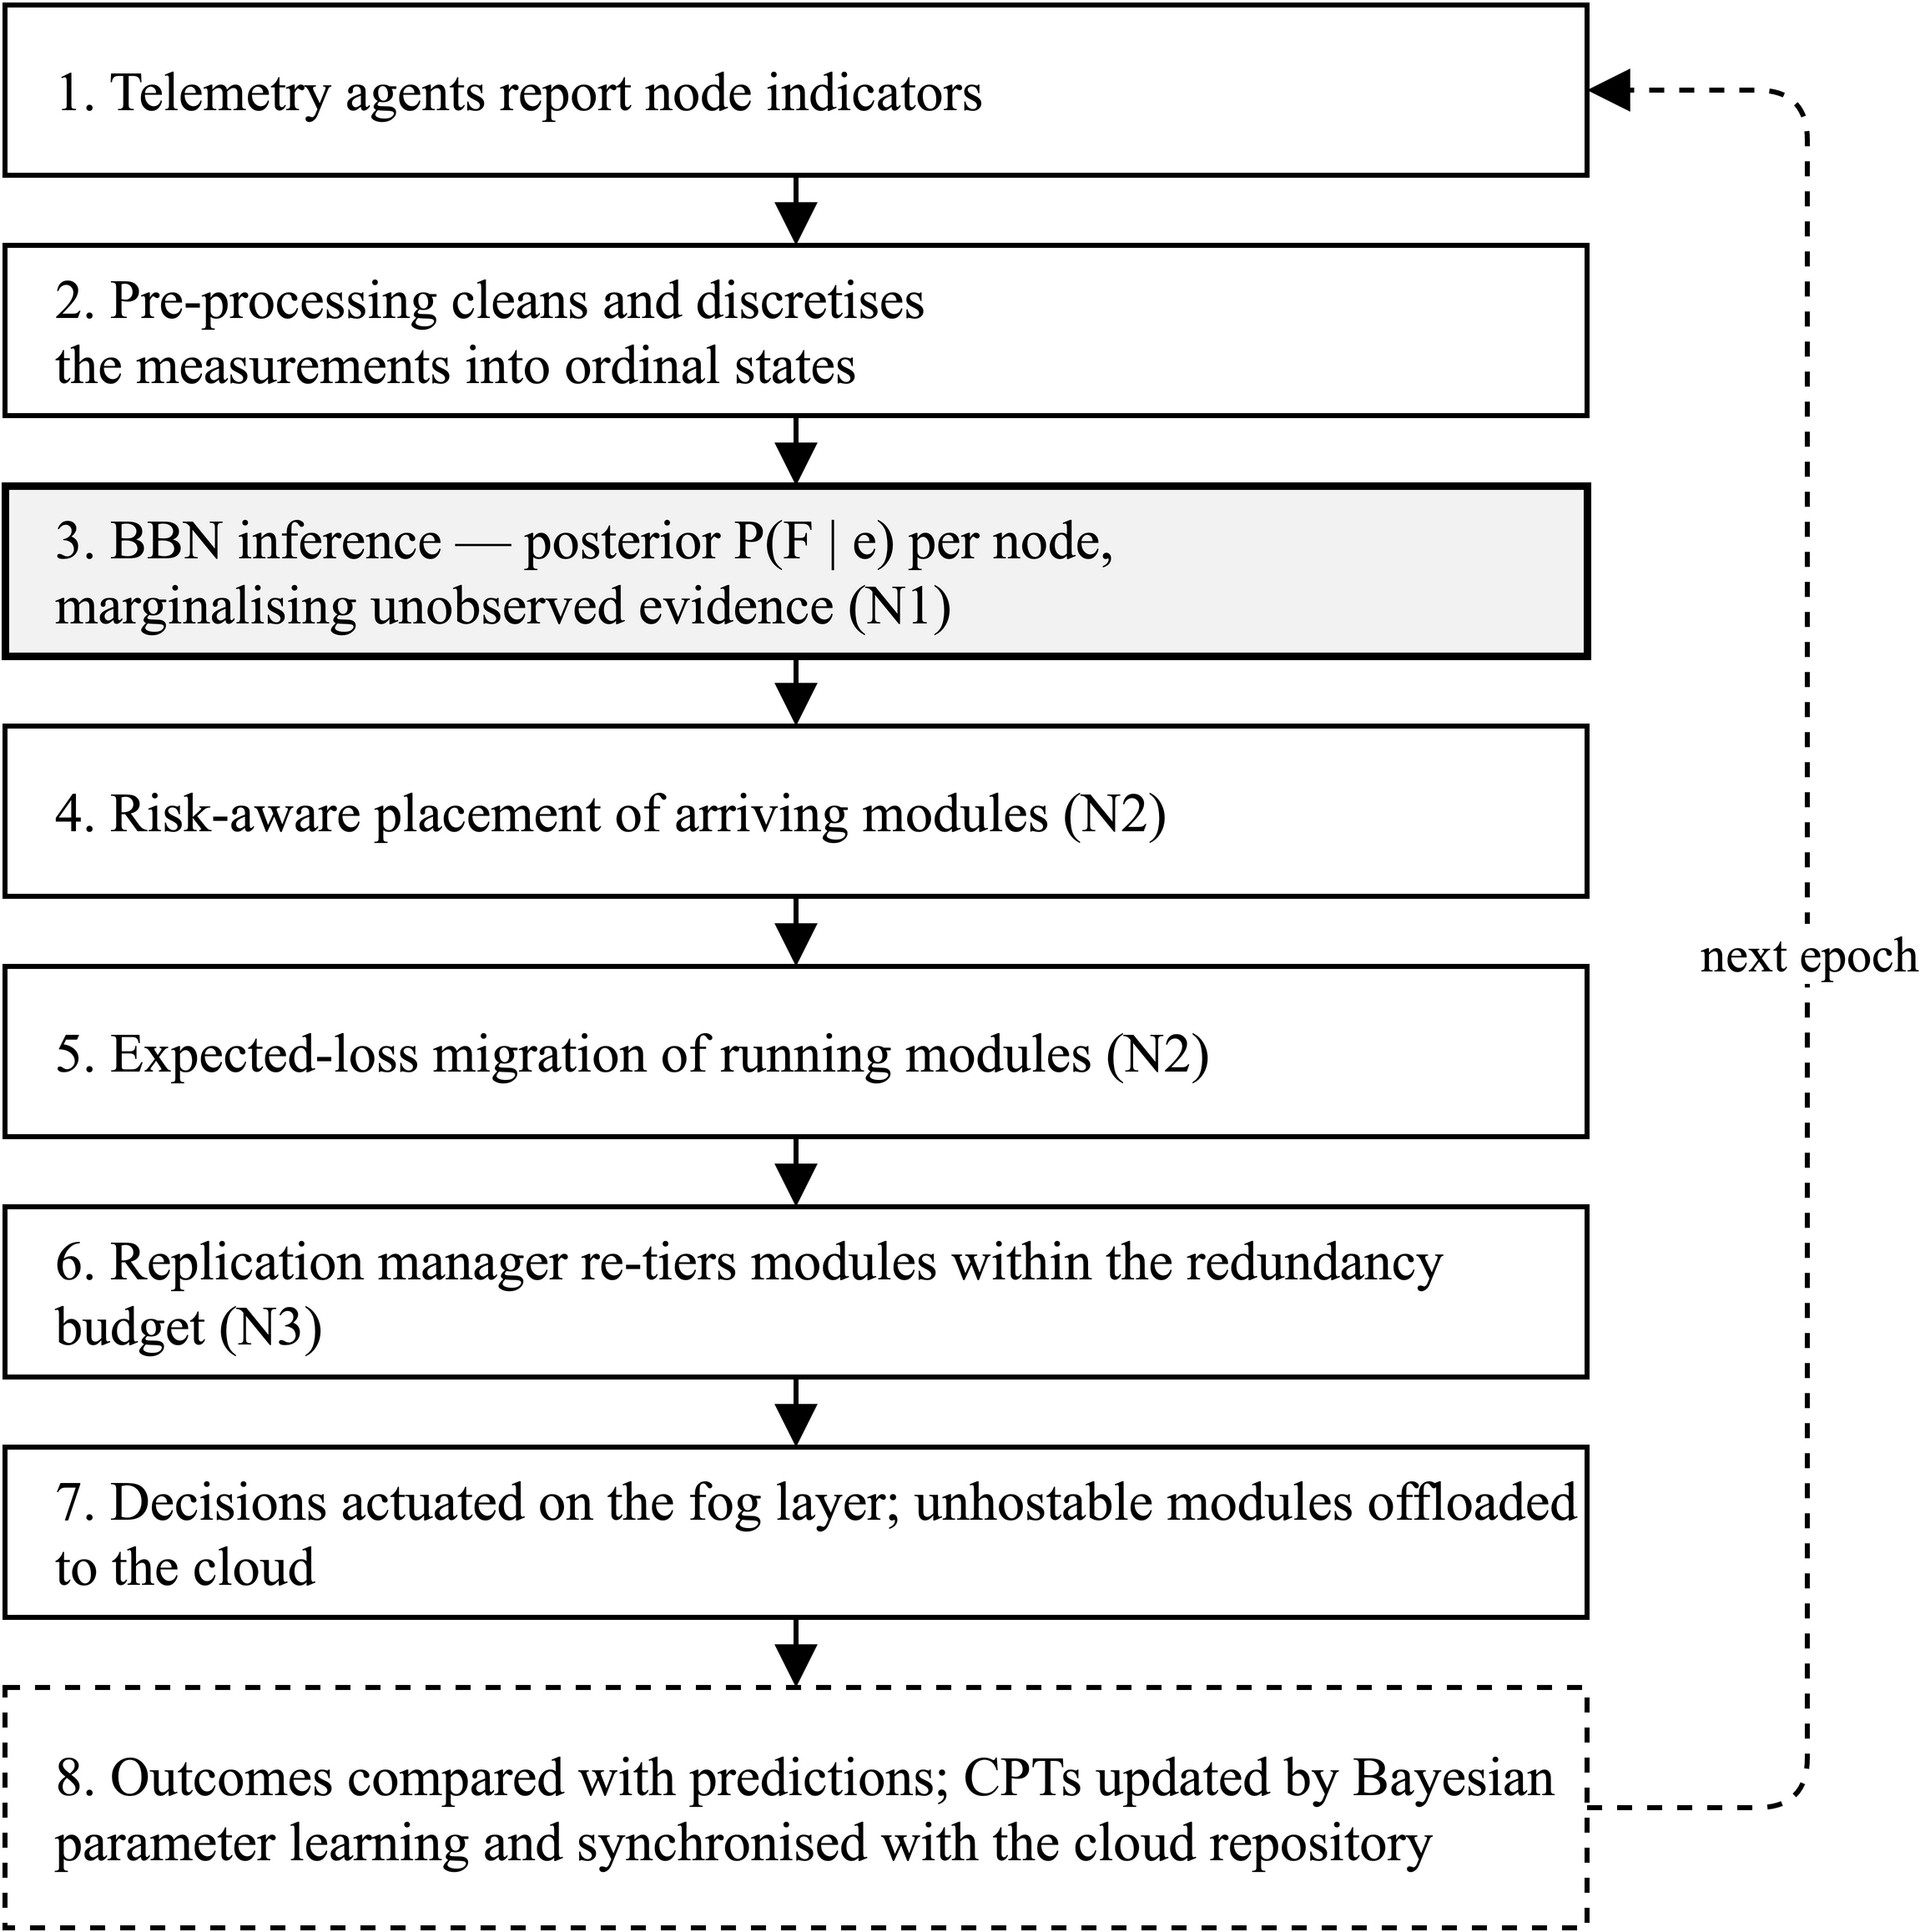
Fig. 3. End-to-end control loop of the proposed framework over one decision epoch. Steps 1-3 perform inference, steps 4-6 convert the posterior into placement, migration and replication decisions, step 7 actuates those decisions on the fog layer and offloads whatever the fog cannot host, and step 8 closes the loop by updating the conditional probability tables from observed outcomes and synchronising them with the cloud repository, so that the model becomes progressively better calibrated to the deployment it governs.
IV. Experimental Setup and Dataset Description
A. Simulation Environment
The framework is being implemented as an extension to iFogSim2 (Mahmud et al. 2022), the widely used discrete-event simulator for edge and fog resource management, which builds on CloudSim and on the original iFogSim toolkit (Gupta et al. 2017). iFogSim2 is selected because it already provides the three capabilities the evaluation requires: mobility support driven by real and synthetic location traces, microservice orchestration with horizontal scaling and service discovery, and dynamic clustering of fog nodes. The proposed controller is realised as a new placement logic registered with the microservices controller, so that it can be compared against the simulator's existing placement policies under identical topologies and workloads. Because iFogSim2 does not model node failure natively, a fault-injection harness is being added that fails nodes according to configurable stochastic processes conditioned on their simulated load, energy and link state, thereby generating both the failure events to be predicted and the ground truth against which predictions are scored.
B. Dataset Description
Three categories of data drive the evaluation. The physical topology is taken from the Melbourne central business district edge-resource dataset distributed with iFogSim2, which enumerates 131 edge and fog resources with their geographic coordinates and parent-child relationships across a four-level hierarchy of cloud data centre, proxy server, gateway and end user. User mobility is supplied both by a real trace of 87 recorded positions and by five synthetic traces of 100 positions each, generated by the simulator's random mobility generator; mobility matters here because handover is one of the evidence variables in the network and a driver of load redistribution. Application workloads comprise three models: a cardiovascular health-monitoring application structured as a client module feeding two downstream analysis microservices, an intelligent surveillance application in which a motion detector, object detector and object tracker drive a pan-tilt-zoom actuator, and a virtual-reality gaming application in which electroencephalogram data is classified and fed to a global coordinator. A configuration file accompanying the microservice application supplies ten distinct application profiles specifying per-microservice processing requirements, inter-module network loads, per-hop latencies, throughput and budget constraints, and these parameters define the operating envelope from which the evidence variables are derived.
It should be stated plainly that no public failure-trace dataset exists for a fog topology of this kind. Failure events are therefore synthesised by the injection harness described above, and the conditional probability tables are seeded from priors reported in the reliability literature (Fenton, Neil, and Marquez 2007; Weber et al. 2012; Pang and Abramov 2025) before being adapted online. Validating the framework against a real fog failure trace, should one become available, is identified as future work.
C. Evaluation Metrics and Baselines
The framework will be assessed along two axes. Prediction quality will be measured by precision, recall and F1 score of failure prediction within the look-ahead horizon, by the calibration of the posterior against observed failure frequency, and by lead time — the interval between a prediction crossing the decision rule and the actual failure — since a prediction that arrives too late to act upon has no operational value. System quality will be measured by mean and tail end-to-end application loop delay, deadline-violation ratio for critical loops, total energy consumption across cloud, fog and end-device tiers, network usage, execution cost, service downtime per injected failure, and redundancy overhead expressed as reserved standby capacity. Robustness will be probed by withholding telemetry channels at inference time to quantify the degradation of prediction quality under partial evidence.
Four baselines will be compared under identical conditions: cloud-only placement; the default edgeward placement of iFogSim2 with no fault tolerance; reactive checkpointing with primary-backup replication in the manner of Rajab and Younis (2021); and threshold-based proactive migration in the manner of FTAPA (Gupta and Singh 2025), which is the closest competitor and the most informative comparison, since it isolates the contribution of probabilistic inference from the contribution of acting early.
V. Conclusion and Future Work
This paper has argued that fault tolerance in fog computing remains predominantly reactive, and that the proactive mechanisms so far reported reduce an inherently uncertain judgement to a fixed threshold on a single metric. A survey of five representative fog fault-tolerance systems found that none quantifies the probability of imminent node failure, none reasons under partial telemetry, and none modulates redundancy by predicted risk. Drawing on an established body of work applying Bayesian Belief Networks to reliability and dependability, the paper has proposed a framework in which a causal BBN infers the posterior probability of fog node failure from noisy and possibly incomplete evidence, a risk-aware utility and an expected-loss decision rule convert that posterior into placement and pre-emptive migration decisions, and a criticality-aware scheme allocates standby capacity in proportion to risk and consequence. The architecture, its block diagram and its workflow have been presented, together with the simulation environment and the datasets on which it will be evaluated.
Work in Phase II will proceed in four stages: construction and expert validation of the BBN structure and its initial conditional probability tables; implementation of the inference engine and the fault-injection harness within iFogSim2; implementation of the risk-aware placement, expected-loss migration and selective replication policies as an iFogSim2 placement logic; and comparative evaluation against the four baselines across the metrics enumerated in Section IV. Longer-term extensions include a dynamic Bayesian network formulation to model the temporal evolution of node degradation explicitly, and distributed inference across clustered fog nodes to remove the controller as a single point of failure.
References
Aguilera, P. A., A. Fernández, R. Fernández, R. Rumí, and A. Salmerón. "Bayesian networks in environmental modelling." Environmental Modelling & Software 26, no. 12 (2011): 1376-1388.
Fenton, Norman, Martin Neil, and David Marquez. "Using Bayesian networks to predict software defects and reliability." In Proceedings of the 5th International Conference on Mathematical Methods in Reliability (MMR07). Glasgow, UK, 2007.
Gupta, Harshit, Amir Vahid Dastjerdi, Soumya K. Ghosh, and Rajkumar Buyya. "iFogSim: A toolkit for modeling and simulation of resource management techniques in the Internet of Things, Edge and Fog computing environments." Software: Practice and Experience 47, no. 9 (2017): 1275-1296.
Gupta, Shally, and Nanhay Singh. "Optimized fault-tolerant placement of microservices in distributed fog networks." International Journal of Data Informatics and Intelligent Computing 4, no. 4 (2025): 52-69.
Hasan, Dathar Abas, and Subhi R. M. Zeebaree. "Proactive fault tolerance in distributed cloud systems: A review of predictive and preventive techniques." Indonesian Journal of Computer Science 13, no. 2 (2024).
Mahmud, Redowan, Samodha Pallewatta, Mohammad Goudarzi, and Rajkumar Buyya. "iFogSim2: An extended iFogSim simulator for mobility, clustering, and microservice management in edge and fog computing environments." Journal of Systems and Software 190 (2022): 111351.
Naim, Mohd Hariz, Jasni Mohamad Zain, and Kamarularifin Abd Jalil. "Fault tolerance mechanism for software application through fog computing as middleware." International Journal of Computing and Digital Systems 5, no. 3 (2016).
Pang, Bo, and Evgeny S. Abramov. "Reliability analysis and parameter selection for IoT communication based on deep learning." Eng 6, no. 8 (2025): 171.
Pearl, Judea. Probabilistic Reasoning in Intelligent Systems: Networks of Plausible Inference. San Mateo, CA: Morgan Kaufmann, 1988.
Rajab, Hadeel T., and Manal F. Younis. "Dynamic fault tolerance aware scheduling for healthcare system on fog computing." Iraqi Journal of Science (2021): 308-318.
Reyana, A., Sandeep Kautish, Khalid Abdulaziz Alnowibet, Hossam M. Zawbaa, and Ali Wagdy Mohamed. "Opportunities of IoT in fog computing for high fault tolerance and sustainable energy optimization." Sustainability 15, no. 11 (2023): 8702.
Syed, Sidra Abid, Munaf Rashid, Samreen Hussain, Fahad Azim, Hira Zahid, Asif Umer, Abdul Waheed, Mahdi Zareei, and Cesar Vargas-Rosales. "QoS aware and fault tolerance based software-defined vehicular networks using cloud-fog computing." Sensors 22, no. 1 (2022): 401.
Weber, Philippe, Gabriela Medina-Oliva, Christophe Simon, and Benoît Iung. "Overview on Bayesian networks applications for dependability, risk analysis and maintenance areas." Engineering Applications of Artificial Intelligence 25, no. 4 (2012): 671-682.

